Preliminary Design Document

for “LaneSense: Autonomous Lane Detection RC Car”

Version 1.0

Date: November 1, 2023

Name: Dominic Lau

For Course/Teacher: Mr.Roller (TEJ4M)

Table of Contents
1. Introduction 4
1.1 Project Overview 4
2. Product Design 4
2.1 Block Diagram 4
2.2 Sub-Circuit Descriptions 4
2.2.1 Sub-Circuit #1 (Servo and Raspberry Pi 4) 4
2.2.2 Sub-Circuit #2 ( Brushless Motor, ESC, and Raspberry Pi 4) 5
2.2.3 Sub-Circuit #3 (Camera and Raspberry Pi 4) 6
2.2.4 Sub-Circuit #4 (RF receiver and Raspberry Pi 4) 8
2.2.5 Sub-Circuit #5 (RF Transmitter and Arduino Uno) 8
2.2.6 Sub-Circuit #6 (Joystick and Arduino Uno) 8
2.3 Product Interfaces 9
2.3.1 Internal Interfaces 9
2. External Interfaces 10
2.3.2 External Interfaces 10
3. Scheduling 11
3.1 Tasks 11
3.2 Gantt Chart Schedule 12
APPENDIX 12
Appendix A. Schematic 12
Appendix B. Parts List 13
4. Resources 15

Introduction

Project Overview
This project targets students (high school and college levels) and hobbyists interested in learning about robotics and computer vision. The Lane Detection RC Car is an educational and recreational project featuring a remote-controlled car with a camera for autonomous lane detection. Users can switch between autonomous and manual modes for learning and fun.

Product Design

Block Diagram
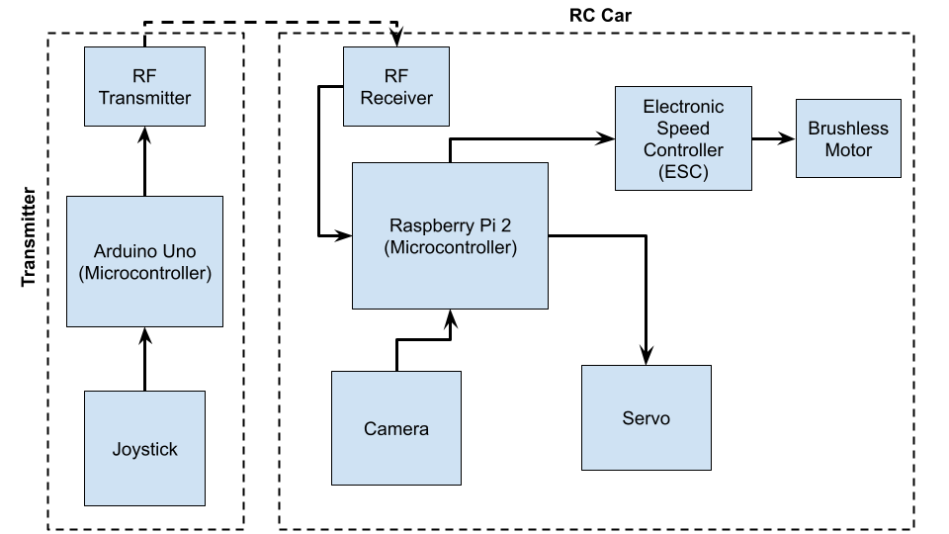

Sub-Circuit Descriptions

Sub-Circuit #1 (Servo and Raspberry Pi 4)
In this sub-circuit, it will describe the integration of a servo motor with a Raspberry Pi 4. The servo motor will be controlled by the Raspberry Pi to perform precise angular movements. This sub-circuit is a fundamental part of the project and will be used to control the orientation of the RC car.

Servo Operation:
- It operates using pulse-width modulation (PWM) signals. By sending PWM signals to the servo motor, it angular position can be precisely controlled. The duty cycle of the PWM signal determines the angle to which the servo motor shaft should be positioned.

Control:

- To control the DS3235-180 servo motor, use the RPi.GPIO library or a similar library. This library allows the GPIO pins to be configured, read, and write GPIO pins.
- Configure the GPIO pin as PWM output and set the PWM frequency and duty cycle based on the servo's specifications.

Pulse Width Modulation (PWM):

PWM changes the voltage of a motor by turning it on and off. This makes the motor get less power on average than what it would get with a steady voltage. The amount of time it's on is the duty cycle. The time between on-off cycles is the period. Here's a basic idea of PWM:
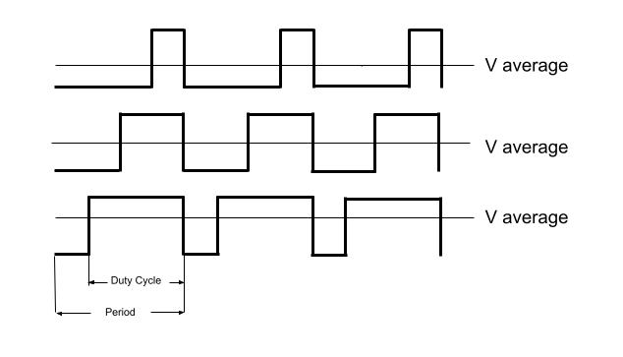

Sub-Circuit #2 ( Brushless Motor, ESC, and Raspberry Pi 4)
In this sub-circuit, we will detail the integration of a brushless motor, an Electronic Speed Controller (ESC), and a Raspberry Pi 4.

Functional Description:

1. Brushless Motor Operation:
- Brushless motors operate by requiring specific sequences of power applied to their three wires to generate rotational movement.
- The speed and direction of the motor are determined by the timing and sequence of the electrical pulses sent to the motor's three wires from the ESC.

2. Electronic Speed Controller (ESC):
- The ESC serves as an intermediary between the Raspberry Pi and the brushless motor. It translates the PWM signals from the Raspberry Pi into motor control actions.
- It interprets the PWM signal to adjust the motor's speed and direction as commanded by the Raspberry Pi.

3. Raspberry Pi 4 GPIO Control:
- The Raspberry Pi 4 has GPIO pins that can be configured to generate PWM signals for controlling the ESC.
- The PWM signals sent by the Raspberry Pi control the ESC, which, in turn, adjusts the brushless motor's speed and direction.

2. Software Control:
- To control the Brushless Motor, use the RPi.GPIO library or a similar library. This library allows the GPIO pins to be configured, read, and write GPIO pins.
- Configure the Raspberry Pi GPIO pin as a PWM output and set the PWM frequency and duty cycle to control the motor's speed and direction.

Sub-Circuit #3 (Camera and Raspberry Pi 4)

The purpose of Sub-Circuit #3 is to process the visual input captured by the camera mounted on the RC car and provide essential data for autonomous lane keeping. This sub-circuit utilizes OpenCV, a powerful open-source computer vision library, to perform real-time image analysis. The processed data is crucial for identifying lane markings and centering the car within the lane.

Image Processing:
This segment focuses on converting visual input into actionable data and detecting lane markings for precise navigation. The key stages include:

- Grayscale Conversion: Transforms color images into grayscale format, simplifying image analysis.
  - Grayscale value = (Red + Green + Blue) / 3
- Noise Reduction with Gaussian Blur: Applies Gaussian blur to reduce noise and enhance image quality, crucial for edge detection.
  - New pixel value = Weighted average of neighboring pixels
- Canny Edge Detection: Detects edges by comparing pixel intensity to predefined thresholds.
  - Compares pixel intensity to predefined thresholds.
    - Implement with ‘cv2.Canny(image, low_threshhold, high_threshold)
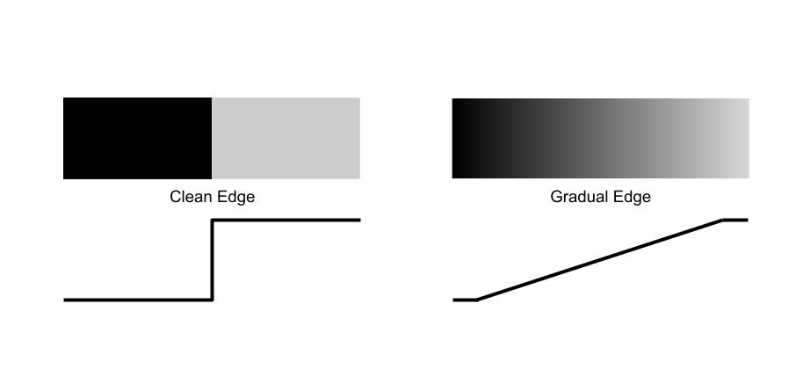

- Apply a Mask: Apply a mask to identify region of interest.
  - Create a binary mask that highlights the region of interest.
  - Combine the original image with the mask using the binary ‘AND’ operation
  - The output shows only the part of the image with the expected lanes, simplifying lane detection processes.
- Hough Transform: Applies Hough Transform to identify lines within the image.

PID Control:
This phase implements a PID controller to calculate and apply real-time steering adjustments, ensuring the RC car stays centered within the lane. The primary components include:

- Set the Desired Lane Center: Define the target position within the image where the car should stay.
- Calculate the Error: Quantify the deviation from the desired lane center by finding the difference between the desired center and the actual position.
  - Error = desired center – actual position
- Calculate Proportional, Integral, and Derivative Terms:
  - Proportional (P) Control: Steers the car proportionally to the error.
    - P = error * P-gain
  - Derivative (D) Term: Prevents overshooting and oscillations.
    - (error – previous error) *D-gain
  - Integral (I) Term: Eliminates long-term bias and improves accuracy.
    - I = (I + error) * I-gain
- Combine PID Terms: Calculate the correction signal for steering adjustments.
  - Correction = P + I + D
- Apply Correction to the Car's Steering: Adjust the car's steering in real-time based on the correction signal.
- Repeat Continuously: Continuously apply the PID control loop while the car is in motion, enabling dynamic real-time correction of the car's position within the lane.

Sub-Circuit #4 (RF receiver and Raspberry Pi 4)

In this sub-circuit, it will outline the integration of an NRF24L01 wireless communication module with a Raspberry Pi 4 using the RF24 library.

The NRF24L01 module is a wireless transceiver that operates in the 2.4GHz. In this case, it will be used as a receiver. It uses SPI for communication with microcontrollers like the Raspberry Pi.

The RF24 library provides functions and methods to interface with the NRF24L01 module, making it easier to send and receive data wirelessly.

Sub-Circuit #5 (RF Transmitter and Arduino Uno)

In this sub-circuit, it will outline the integration of an RF (Radio Frequency) transmitter with an Arduino Uno. The RF transmitter is a key component that allows wireless data transmission and remote control of the RC car.

RF Transmitter Operation:
- The RF transmitter module transmits wireless signals at 2.4GHz
- It generates wireless signals for data transmission upon instructions from the Arduino.
- Arduino Uno's digital pins can be set as outputs.
- Configuring a digital pin allows the Arduino to send data to the RF transmitter for wireless transmission.

The RF24 library provides functions and methods to interface with the NRF24L01 module, making it easier to send and receive data wirelessly.

Sub-Circuit #6 (Joystick and Arduino Uno)
Joystick Module: The joystick module consists of two potentiometers, one for the X-axis and another for the Y-axis, which generate analog signals corresponding to the joystick's position. When the user moves the joystick, it changes the resistance along these axes, creating variable voltage outputs between 0V and 5V. These analog signals are then read by the Arduino Uno.

The Arduino Uno is responsible for reading the analog values from the joystick module and interpreting them for further action. It has analog pins (A0, A1) that are connected to the analog output pins of the joystick module.

Data Processing: The Arduino reads the analog voltages from the joystick and maps them to suitable numerical values within a specific range. For example, it may convert the analog voltage to values between 0 and 1023 using the 'analogRead()' function. These values are then used to determine the position of the joystick.

Product Interfaces

Internal Interfaces

Internal Interface #1: Raspberry Pi and Electronic Speed Controller (ESC)

This interface is essential for communication between the Raspberry Pi and the Electronic Speed Controller (ESC), which controls the DC motor responsible for driving the wheels. It enables the Raspberry Pi to send control signals to the ESC for motor speed regulation and direction.

Signal Name | From (Reference Designator) | To (Reference Designator) | Pin on 'From' | Pin on 'To'
ESC_PWM | U1-A (Raspberry Pi) | U3 (ESC) | 3 | 1
ESC_GND | U1-A (Raspberry Pi) | U3 (ESC) | 2 | 2

Communication Protocol:
ESC Communication (ESC PWM and ESC GND): The communication protocol for this interface involves the Raspberry Pi sending Pulse Width Modulation (PWM) signals to the Electronic Speed Controller (ESC). The duty cycle of the PWM signals sent through the 'ESC_PWM' pin controls the speed of the connected DC motor. Ground reference is provided through the 'ESC_GND' pin.

Internal Interface #2: Electronic Speed Controller and DC Motor

This interface establishes the connection between the Electronic Speed Controller (ESC) and the DC motor. It is responsible for translating control signals from the ESC into actual motor speed and direction.

Signal Name | From (Reference Designator) | To (Reference Designator) | Pin on 'From' | Pin on 'To'
Phase_A | U3 (ESC) | M1 (DC brushless motor) | Phase_A | A
Phase_B | U3 (ESC) | M1 (DC brushless motor) | Phase_B | B
Phase_C | U3 (ESC) | M1 (DC brushless motor) | Phase_C | C

Communication Protocol:
The communication protocol in this interface involves the Raspberry Pi sending Pulse Width Modulation (PWM) signals to the ESC which will change the direction and speed of the motor.

Internal Interface #3: Raspberry Pi and Servo Motor

The interface between the Raspberry Pi and the Servo Motor enables the Raspberry Pi to control the orientation of the servo motor. This is essential for steering the car.

Signal Name | From (Reference Designator) | To (Reference Designator) | Pin on 'From' | Pin on 'To'
Servo_PWM | U1-A (Raspberry Pi) | S1 (Servo Motor) | GPIO 16 | 1
GND | U1-A (Raspberry Pi) | S1 (Servo Motor) | GPIO 14 | 3
Power Supply | U1-A (Raspberry Pi) | S1 (Servo Motor) | GPIO 2 | 2

Communication Protocol:
The communication protocol in this interface involves the Raspberry Pi sending Pulse Width Modulation (PWM) signals to the Servo Motor. These signals determine the position of the motor's shaft.

Internal Interface #4: Arduino and Transmitter

Signal Name | From (Reference Designator) | To (Reference Designator) | Pin on ‘From’ | Pin on ‘To’
Power Supply (3.3V) | Arduino (A1) | Transmitter (NRF24L01) | 3.3V | VCC
Ground | Arduino (A1) | Transmitter (NRF24L01) | GND | GND
Chip Enable | Arduino (A1) | Transmitter (NRF24L01) | 13 (SCK) | CE
Chip Select Not | Arduino (A1) | Transmitter (NRF24L01) | 12 (MISO) | CSN
Master Out Slave In | Arduino (A1) | Transmitter (NRF24L01) | 11 (MOSI) | MOSI
Interrupt Request | Arduino (A1) | Transmitter (NRF24L01) | 10 | IRQ

It uses Serial Peripheral Interface (SPI)

- The master (A1) activates the CSN line to select the slave (NRF24L01) with which it wants to communicate.
- The master sends clock pulses (SCK) to synchronize data transmission.
- While the clock pulses are being sent, data is transmitted from the master to the slave (MOSI), and from the slave to the master (MISO) simultaneously.
- The master and slave devices must be configured to sample data on the same edge of the clock signal.

External Interfaces

External Interface #1 Camera Module to Microcontroller

Connector Type: MIPI CSI-2 (Mobile Industry Processor Interface Camera Serial Interface 2).

Protocol: MIPI CSI-2
The camera module communicates with the microcontroller through MIPI CSI-2, a high-speed serial interface designed for transmitting video data. The power supply and ground connections provide electrical power, while the video data is sent over CAM_D0.

External Interface #2 Joystick to Arduino
Signal Name | From (Reference Designator) | To (Reference Designator) | Pin on 'From' | Pin on 'To'
Ground | Arduino (A1) | Joystick (J1) | GND | GND
Power Supply (5V) | Arduino (A1) | Joystick (J1) | 5V | VCC
VRx | Joystick (J1) | Arduino (A1) | VRx | A0
VRy | Joystick (J1) | Arduino (A1) | VRy | A1
Btn | Joystick (J1) | Arduino (A1) | SW | 9

The Arduino uses the 'analogRead()' function to read the voltage level from the analog pins. The function returns a value between 0 and 1023, where 0 represents the minimum voltage (0V), and 1023 represents the maximum voltage (5V). This allows the Arduino to determine the Joystick's general position.

Reading the Button State (Digital Signal):
- The button on the joystick generates a digital signal. It is usually either HIGH (1) when the button is not pressed or LOW (0) when the button is pressed.
- The Arduino uses the 'digitalRead()' function to check the state of the button. It returns either HIGH or LOW, indicating the button's status.

External Interface #3 Receiver to Raspberry Pi

Signal Name | From (Reference Designator) | To (Reference Designator) | Pin on 'From' | Pin on 'To'
Power Supply (3.3V) | U1-A (Raspberry Pi) | Receiver (NRF24L01) | 3.3V | VCC
Ground | U1-A (Raspberry Pi) | Receiver (NRF24L01) | GND | GND
Chip Enable | U1-A (Raspberry Pi) | Receiver (NRF24L01) | 13 (SCK) | CE
Chip Select Not | U1-A (Raspberry Pi) | Receiver  (NRF24L01) | 12 (MISO) | CSN
Master Out Slave In | U1-A (Raspberry Pi) | Receiver  (NRF24L01) | 11 (MOSI) | MOSI
Interrupt Request | U1-A (Raspberry Pi) | Receiver  (NRF24L01) | 10 | IRQ

Scheduling

Tasks
- Obtain CAD .stl files for the RC car.
- 3D print all .stl files.
- Create a schematic.
- Order the necessary parts.
- Assemble the RC car using the ordered parts.
- Wire all the electronics.
- Write code to control the movement of the RC car.
- Write code to enable remote control of the RC car.
- Implement lane detection, initially in simulation only.
- Integrate vision capabilities with the RC car.

Gantt Chart Schedule
Gantt Chart - LaneSense: Autonomous Lane Detection RC Car
APPENDIX
- Schematic
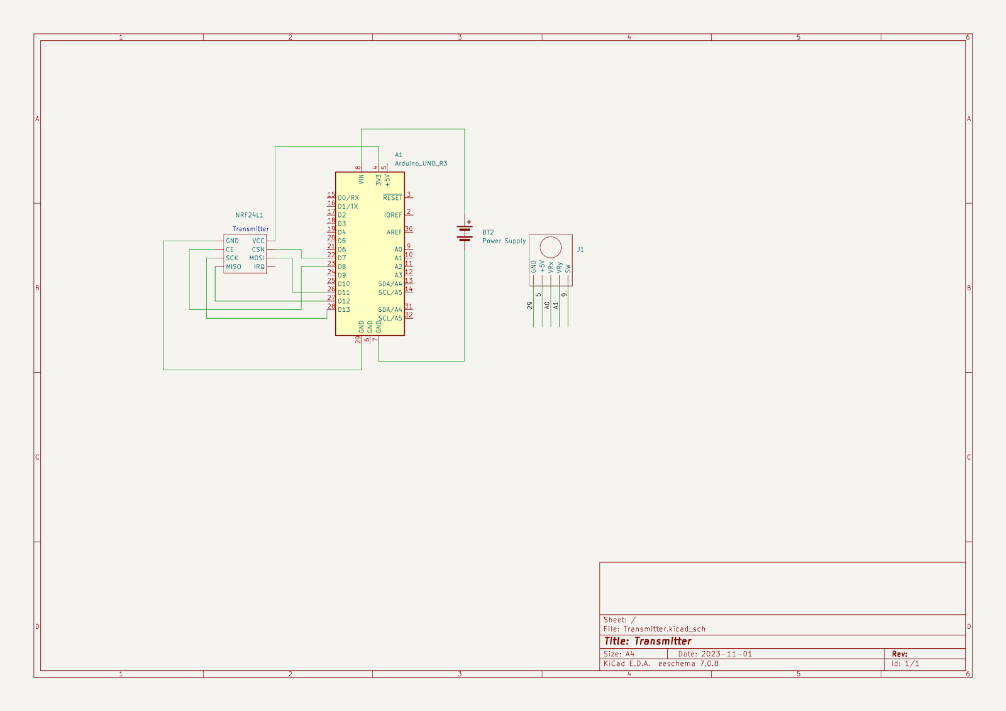
- Parts List
Reference Designator | Quantity | Part Descriptors | Link to product
U1 | 1 | Raspberry Pi 4 | https://www.raspberrypi.com/products/raspberry-pi-4-model-b/
U2 | 1 | nrf24l01 transceiver module | https://www.amazon.ca/Aideepen-NRF24L01-Wireless-Transceiver-Antenna/dp/B01ICU18XC/ref=sr_1_2_sspa?hvadid=588772360491&hvdev=c&hvlocphy=9000686&hvnetw=g&hvqmt=e&hvrand=13794299723503084221&hvtargid=kwd-424558360700&hydadcr=18976_13393163&keywords=nrf24l01%2Btransceiver%2Bmodule&qid=1698252538&sr=8-2-spons&sp_csd=d2lkZ2V0TmFtZT1zcF9hdGY&th=1
U3 + M1 | 1 | MOT-QC-KIT01 A2212 1000KV Brushless Motor Kit with 30A ESC and Propellers For RC Quadcopters Planes Boats Vehicles and DIY Kits | https://abra-electronics.com/quadcopters/motors/mot-qc-kit01-a2212-1000kv-brushless-motor-kit-with-30a-esc-and-propellers-for-rc-quadcopters-planes-boats-vehicles-and-diy-kits.html
U4 | 1 | PI-CAMERA-4, 5MP Fisheye Camera, 70 Degrees for Raspberry Pi | https://abra-electronics.com/robotics-embedded-electronics/raspberry-pi-en-3/cameras-en-2/pi-camera-4.html
S1 | 1 | 1X Waterproof Servo 30Kg High Speed servo Metal Gear Digital Servo RC Baja Servo For 1/8 1/10 Scale RC Cars | https://www.aliexpress.com/item/1943129663.html?spm=a2g0o.order_list.order_list_main.44.21ef1802nZ7a4i
U5 | 1 | DeWALT 20V Battery | https://www.amazon.ca/DEWALT-DCB205-5-0Ah-Lithium-Battery/dp/B00KWRM5Z4/ref=sr_1_12?hvadid=604602884320&hvdev=c&hvlocphy=9000685&hvnetw=g&hvqmt=e&hvrand=15155174876082208767&hvtargid=kwd-297477136713&hydadcr=1503_13517072&keywords=dewalt+batteries&qid=1698845780&sr=8-12
U6 | 1 | Digital Low Voltage Disconnect Module, Over Charge/Discharge/Current and Short Circuit Protection for 12-36V DC Battery | https://www.amazon.ca/Digital-Low-Voltage-Protection-Battery/dp/B07929Y5SZ/ref=sr_1_12?crid=2TXCNHN0CZGLW&keywords=digital+low+voltage+disconnect+module&qid=1698754681&sprefix=digital+low+voltage+diconnect+module%2Caps%2C91&sr=8-12
BT1 & BT2 | 2 | Power Bank | https://www.amazon.ca/Anker-PowerCore-Technology-High-Capacity-Compatible/dp/B07S829LBX/ref=sr_1_1_sspa?crid=1QSMRBRK9A69Z&keywords=power%2Bbank%2Banker&qid=1698798378&sprefix=power%2Bbank%2Banke%2Caps%2C129&sr=8-1-spons&sp_csd=d2lkZ2V0TmFtZT1zcF9hdGY&th=1
NRF24L01 (receiver)  +  NRF24L01 (transmitter) | 1 | 2PCS NRF24L01+ 2.4GHz WL Transceiver Module R-F Transceiver Module | https://www.amazon.ca/Aideepen-NRF24L01-Wireless-Transceiver-Antenna/dp/B01ICU18XC/ref=sr_1_3_sspa?crid=3PADNOHUU179Y&keywords=nRF24L01&qid=1698844300&sprefix=nrf24l01%2Caps%2C167&sr=8-3-spons&sp_csd=d2lkZ2V0TmFtZT1zcF9hdGY&th=1

Resources

https://lastminuteengineers.com/nrf24l01-arduino-wireless-communication/
https://www.tytorobotics.com/blogs/articles/how-brushless-motors-work
https://medium.com/@anujdev11/communication-between-arduino-and-raspberry-pi-using-nrf24l01-818687f7f363
https://github.com/nRF24/RF24
https://www.instructables.com/BASICS-OF-THE-SPI-COMMUNICATION-PROTOCOL/
https://docs.arduino.cc/built-in-examples/usb/JoystickMouseControl
https://www.instructables.com/Servo-Motor-Control-With-Raspberry-Pi/
https://www.instructables.com/Driving-an-ESCBrushless-Motor-Using-Raspberry-Pi/
https://www.raspberrypi.com/documentation/accessories/camera.html#:~:text=an%20earthing%20strap.-,Connecting%20the%20Camera,contacts%20facing%20the%20HDMI%20port.
https://www.arducam.com/raspberry-pi-camera-pinout/
https://www.arducam.com/use-almost-any-mipi-camera-module-on-raspberry-pi/#:~:text=The%20MIPI%20cameras%20bring%20a,support%20high%2Dperformance%20camera%20applications.

